MFCC:
Bird species | precision | recall | f1 score | Accuracy | support
RB | 0.99 | 0.96 | 0.97 | 95.83 | 72
GT | 0.99 | 0.85 | 0.91 | 84.61 | 78
WW | 0.88 | 0.92 | 0.9 | 92.3 | 78
EF | 0.8 | 0.88 | 0.84 | 88.31 | 77
CB | 0.96 | 0.94 | 0.95 | 94.44 | 72
CR | 1 | 0.93 | 0.96 | 93.1 | 58
GW | 0.96 | 0.96 | 0.96 | 96.42 | 56
BJ | 0.94 | 0.99 | 0.96 | 98.75 | 80
CS | 0.96 | 0.97 | 0.97 | 97.36 | 76
WD | 0.94 | 0.95 | 0.94 | 95.08 | 61

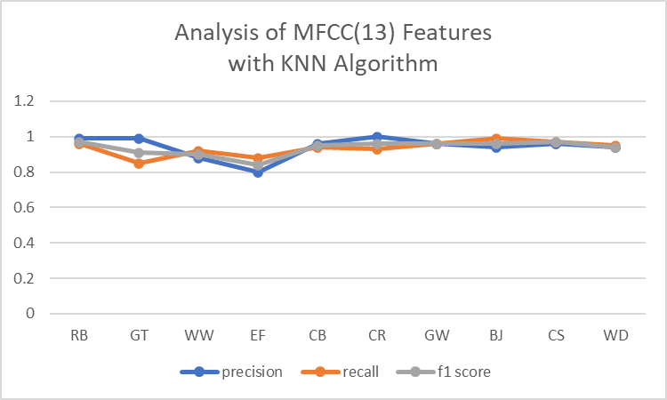
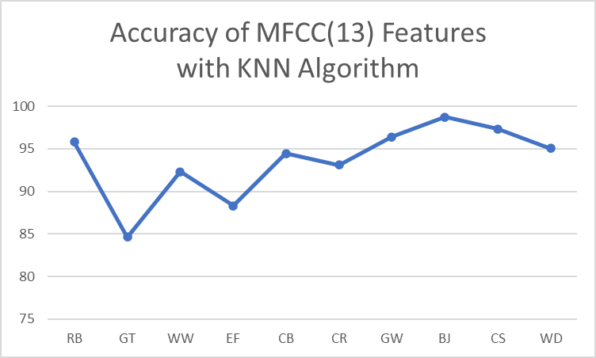
Bird species | precision | recall | f1 score | Accuracy | support
RB | 1 | 0.98 | 0.99 | 98.41 | 63
GT | 0.98 | 0.94 | 0.96 | 94.18 | 86
WW | 0.84 | 0.84 | 0.84 | 83.56 | 73
EF | 0.75 | 0.84 | 0.79 | 83.54 | 79
CB | 0.97 | 0.89 | 0.93 | 88.75 | 80
CR | 0.98 | 0.98 | 0.98 | 98.21 | 56
GW | 0.96 | 1 | 0.98 | 100 | 69
BJ | 0.99 | 0.96 | 0.98 | 96.38 | 83
CS | 0.95 | 1 | 0.98 | 1 | 63
WD | 1 | 0.96 | 0.98 | 96.42 | 56

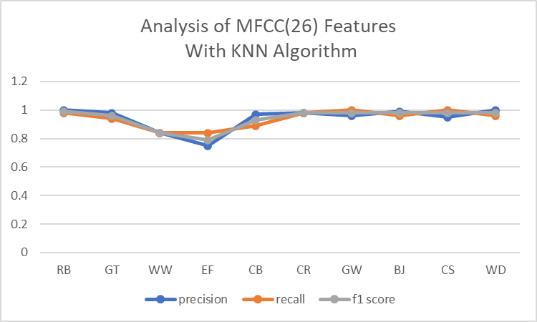
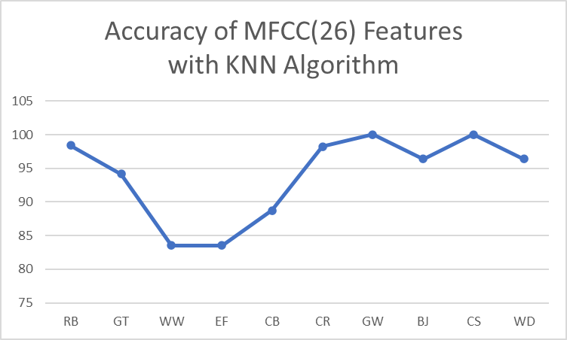

Bird species | precision | recall | f1 score | Accuracy | support
RB | 0.99 | 0.89 | 0.94 | 89.47 | 76
GT | 0.92 | 0.92 | 0.92 | 91.93 | 62
WW | 0.9 | 0.83 | 0.87 | 83.33 | 78
EF | 0.81 | 0.87 | 0.84 | 86.51 | 89
CB | 0.91 | 0.97 | 0.94 | 97.29 | 74
CR | 1 | 1 | 1 | 100 | 48
GW | 0.94 | 0.98 | 0.96 | 98.36 | 61
BJ | 0.97 | 0.98 | 0.97 | 97.7 | 87
CS | 1 | 1 | 1 | 100 | 74
WD | 1 | 0.97 | 0.98 | 96.61 | 59

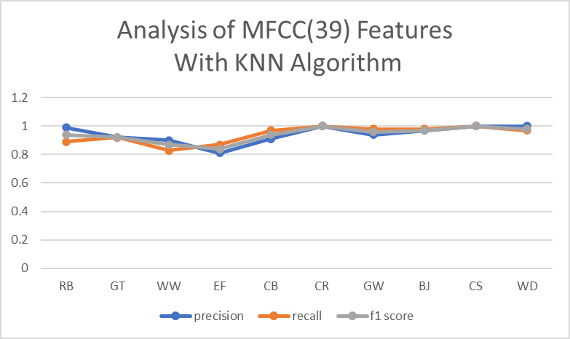
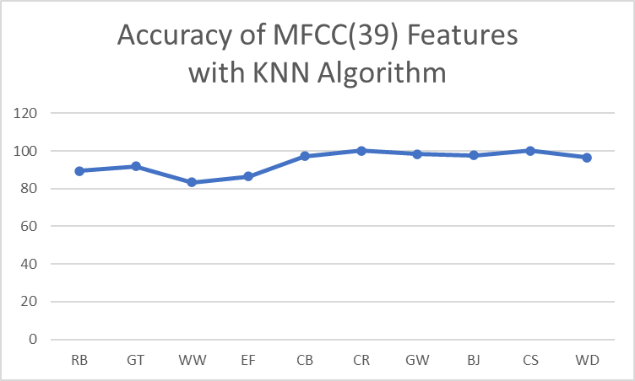

Bird species | precision | recall | f1 score | Accuracy | support
RB | 1 | 0.96 | 0.98 | 96 | 75
GT | 0.98 | 0.98 | 0.98 | 98.48 | 66
WW | 0.88 | 0.82 | 0.85 | 82.43 | 74
EF | 0.79 | 0.888 | 0.83 | 87.8 | 82
CB | 0.99 | 0.9 | 0.94 | 89.53 | 86
CR | 0.97 | 1 | 0.98 | 100 | 59
GW | 0.97 | 1 | 0.99 | 100 | 69
BJ | 0.96 | 1 | 0.98 | 100 | 75
CS | 1 | 1 | 1 | 100 | 67
WD | 0.98 | 0.98 | 0.98 | 98.18 | 55

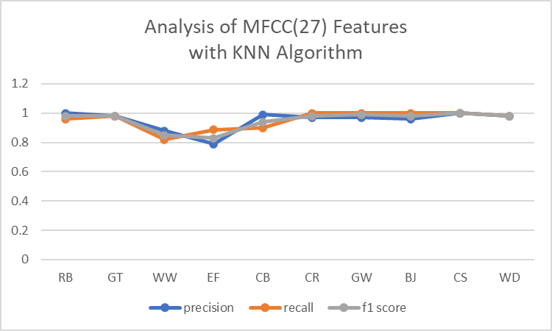
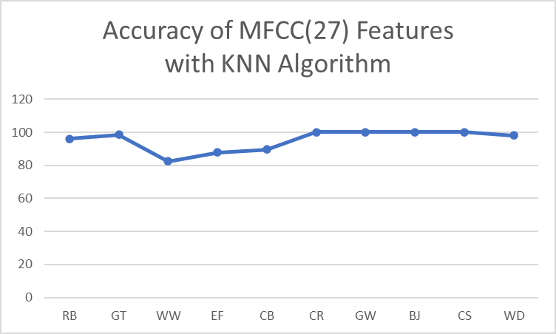

LFCC
Bird species | precision | recall | f1 score | Accuracy | support
RB | 0.95 | 0.99 | 0.97 | 98.57 | 70
GT | 0.88 | 0.94 | 0.91 | 94.2 | 69
WW | 0.88 | 0.81 | 0.85 | 81.33 | 75
EF | 0.82 | 0.76 | 0.79 | 76.25 | 80
CB | 0.93 | 0.9 | 0.92 | 90.21 | 92
CR | 0.9 | 0.98 | 0.94 | 98.21 | 56
GW | 0.95 | 0.9 | 0.92 | 90.16 | 61
BJ | 0.91 | 0.96 | 0.93 | 95.56 | 90
CS | 0.98 | 1 | 0.99 | 100 | 63
WD | 1 | 1 | 1 | 100 | 52

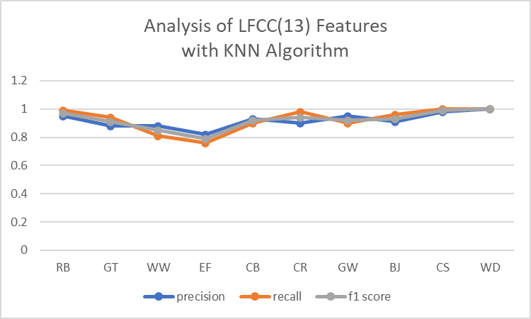
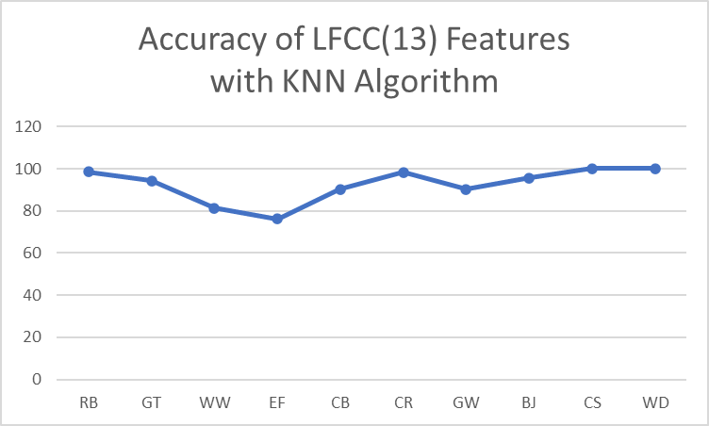
Bird species | precision | recall | f1 score | Accuracy | support
RB | 0.95 | 0.97 | 0.96 | 97.18 | 71
GT | 0.91 | 1 | 0.95 | 100 | 67
WW | 0.84 | 0.87 | 0.85 | 87.01 | 77
EF | 0.83 | 0.81 | 0.82 | 81.39 | 86
CB | 0.97 | 0.9 | 0.94 | 90.12 | 81
CR | 1 | 0.97 | 0.98 | 96.82 | 63
GW | 0.95 | 0.97 | 0.96 | 96.77 | 62
BJ | 0.95 | 0.96 | 0.96 | 96.29 | 81
CS | 0.98 | 0.92 | 0.95 | 91.93 | 62
WD | 0.98 | 0.98 | 0.98 | 98.27 | 58

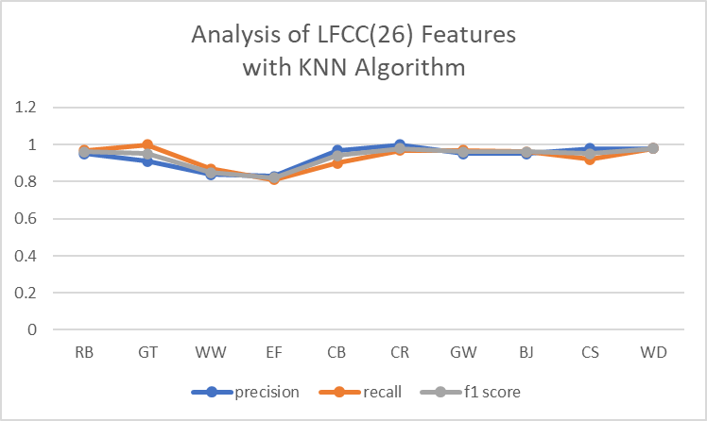
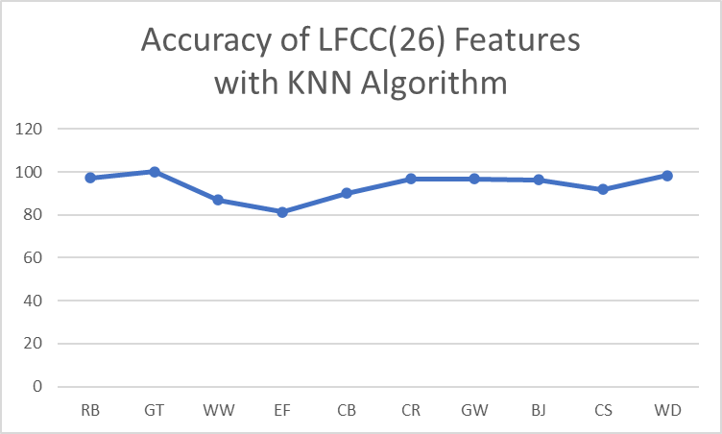

Bird species | precision | recall | f1 score | Accuracy | support
RB | 0.99 | 0.99 | 0.99 | 98.71 | 78
GT | 0.97 | 0.98 | 0.98 | 98.43 | 64
WW | 0.88 | 0.82 | 0.85 | 82.5 | 80
EF | 0.8 | 0.9 | 0.85 | 89.74 | 78
CB | 0.96 | 0.92 | 0.94 | 92.04 | 88
CR | 0.96 | 0.92 | 0.94 | 92.45 | 53
GW | 0.95 | 0.97 | 0.96 | 96.92 | 65
BJ | 1 | 1 | 1 | 100 | 78
CS | 0.99 | 0.96 | 0.97 | 95.83 | 72
WD | 0.94 | 0.98 | 0.96 | 98.07 | 52

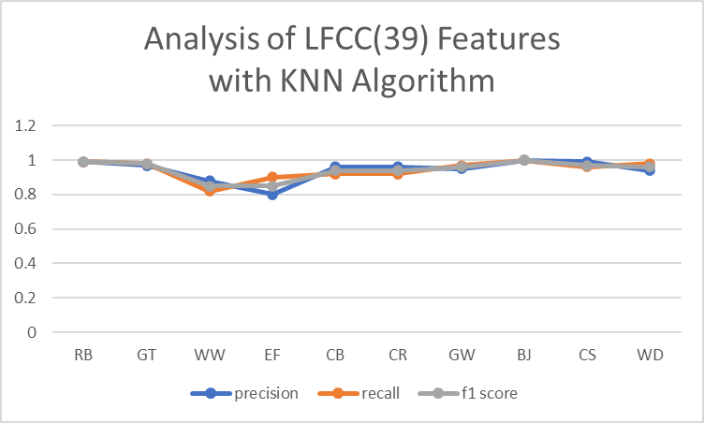
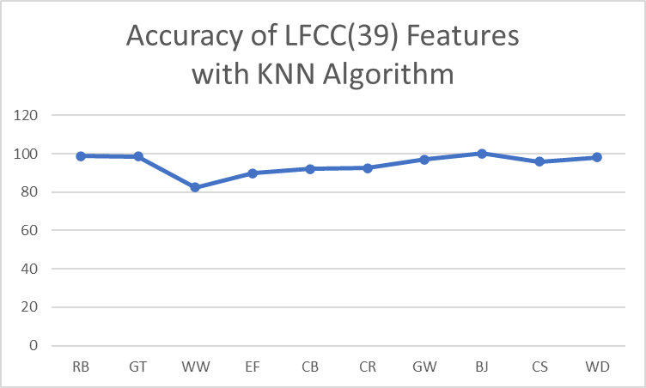

Bird species | precision | recall | f1 score | Accuracy | support
RB | 1 | 0.99 | 0.99 | 98.5 | 67
GT | 0.93 | 0.92 | 0.93 | 92.2 | 77
WW | 0.98 | 0.79 | 0.88 | 79.45 | 73
EF | 0.82 | 0.93 | 0.87 | 92.78 | 97
CB | 0.94 | 0.97 | 0.95 | 97.29 | 74
CR | 0.98 | 1 | 0.99 | 100 | 54
GW | 0.98 | 0.96 | 0.97 | 96.42 | 56
BJ | 0.99 | 0.99 | 0.99 | 98.73 | 79
CS | 0.99 | 0.99 | 0.99 | 98.52 | 68
WD | 1 | 1 | 1 | 100 | 63

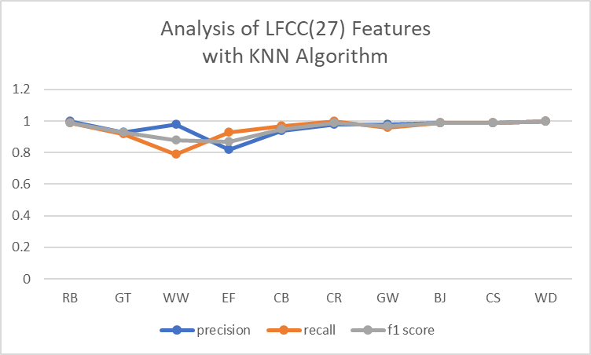

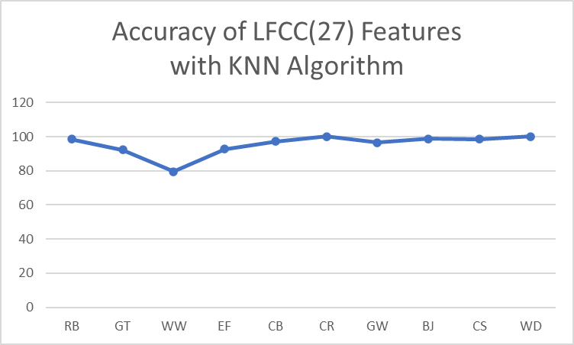

GFCC
Bird species | precision | recall | f1 score | Accuracy | support
RB | 0.97 | 0.93 | 0.95 | 92.85 | 70
GT | 0.99 | 1 | 0.99 | 98.61 | 72
WW | 0.95 | 0.82 | 0.88 | 82.35 | 85
EF | 0.76 | 0.9 | 0.83 | 90.16 | 61
CB | 0.98 | 0.91 | 0.94 | 91.11 | 90
CR | 0.95 | 0.96 | 0.96 | 96.42 | 56
GW | 0.96 | 0.99 | 0.97 | 98.5 | 67
BJ | 0.91 | 0.96 | 0.94 | 96.38 | 83
CS | 0.96 | 0.95 | 0.96 | 94.93 | 79
WD | 0.96 | 0.98 | 0.97 | 97.78 | 45

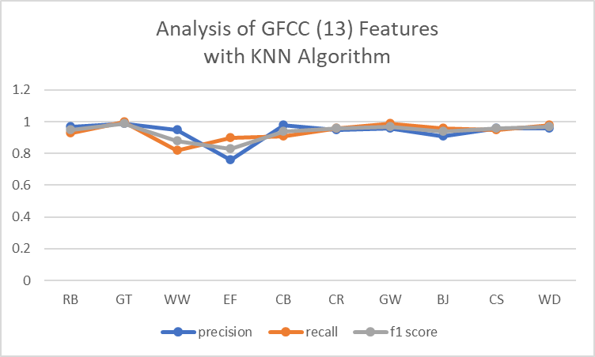
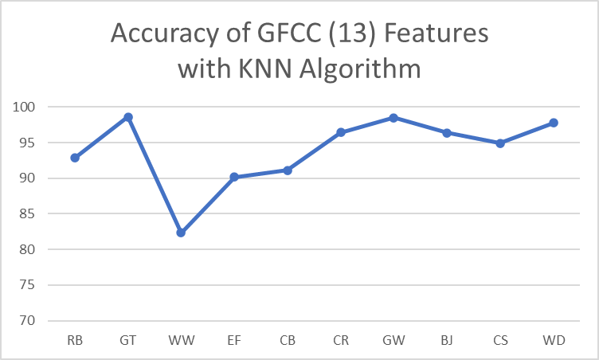

Bird species | precision | recall | f1 score | Accuracy | support
RB | 0.96 | 0.96 | 0.96 | 98.71 | 78
GT | 0.95 | 0.99 | 0.97 | 86.3 | 73
WW | 0.86 | 0.71 | 0.78 | 68.04 | 97
EF | 0.75 | 0.84 | 0.79 | 81.39 | 86
CB | 0.94 | 0.94 | 0.94 | 91.02 | 78
CR | 1 | 1 | 1 | 100 | 73
GW | 0.98 | 0.98 | 0.98 | 95.45 | 66
BJ | 0.94 | 0.96 | 0.95 | 100 | 78
CS | 0.97 | 1 | 0.99 | 95.83 | 72
WD | 0.98 | 0.98 | 0.98 | 98.07 | 52

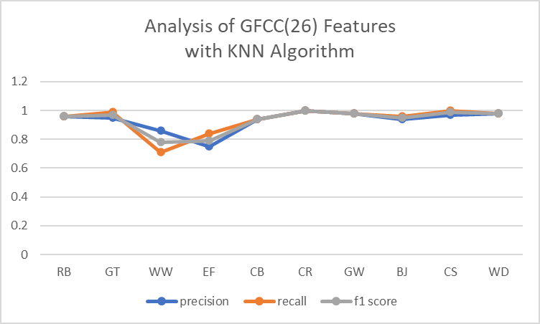
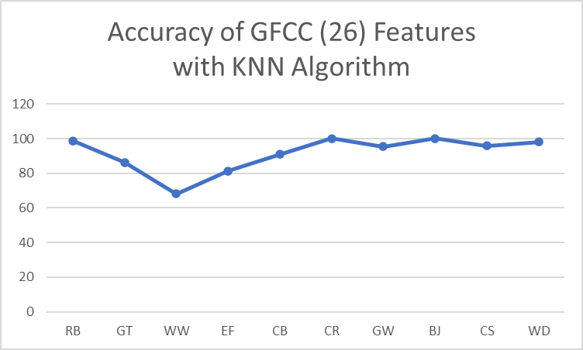

Bird species | precision | recall | f1 score | Accuracy | support
RB | 0.97 | 0.98 | 0.98 | 98.46 | 65
GT | 0.96 | 0.95 | 0.95 | 94.67 | 75
WW | 0.88 | 0.82 | 0.85 | 81.81 | 77
EF | 0.81 | 0.91 | 0.86 | 91.01 | 89
CB | 0.96 | 0.94 | 0.95 | 93.9 | 82
CR | 0.95 | 0.98 | 0.97 | 98.36 | 61
GW | 1 | 0.98 | 0.99 | 98.24 | 57
BJ | 0.99 | 0.91 | 0.95 | 91.02 | 78
CS | 0.96 | 1 | 0.98 | 100 | 75
WD | 0.98 | 0.94 | 0.96 | 93.87 | 49

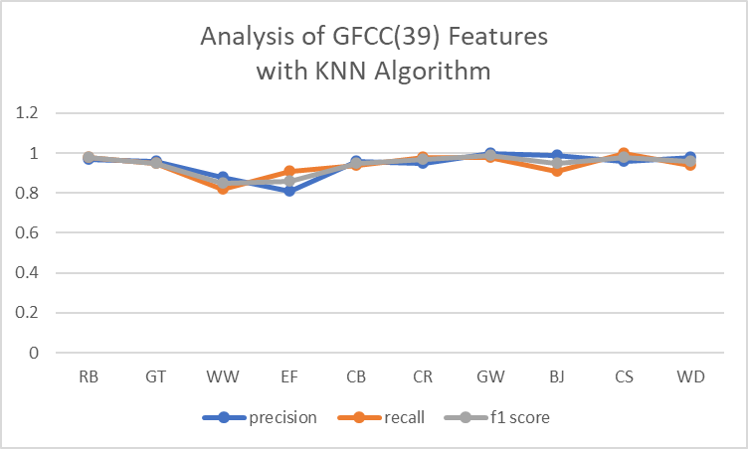
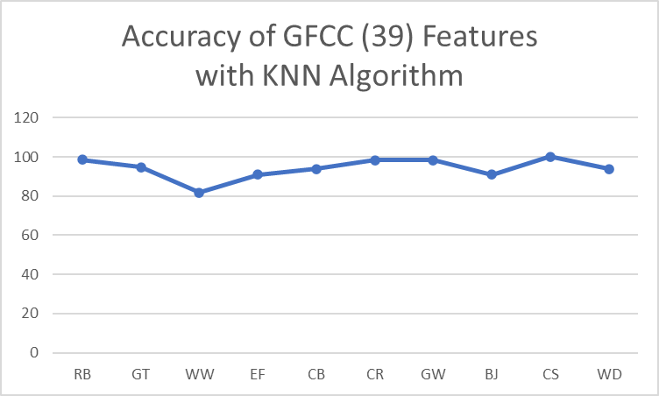

Bird species | precision | recall | f1 score | Accuracy | support
RB | 0.95 | 1 | 0.98 | 79.03 | 62
GT | 0.93 | 0.93 | 0.93 | 64.86 | 74
WW | 0.78 | 0.83 | 0.8 | 60.86 | 69
EF | 0.76 | 0.88 | 0.81 | 55.4 | 74
CB | 0.97 | 0.94 | 0.95 | 88.17 | 93
CR | 0.96 | 0.92 | 0.94 | 62.5 | 48
GW | 0.94 | 0.98 | 0.96 | 96.77 | 62
BJ | 1 | 0.94 | 0.97 | 82.05 | 78
CS | 0.99 | 1 | 0.99 | 60.56 | 71
WD | 0.92 | 0.75 | 0.83 | 46.15 | 65

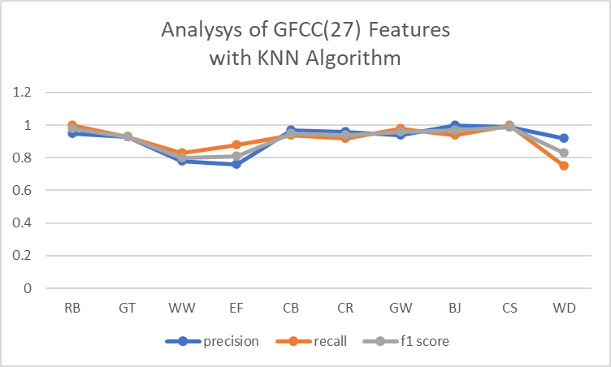
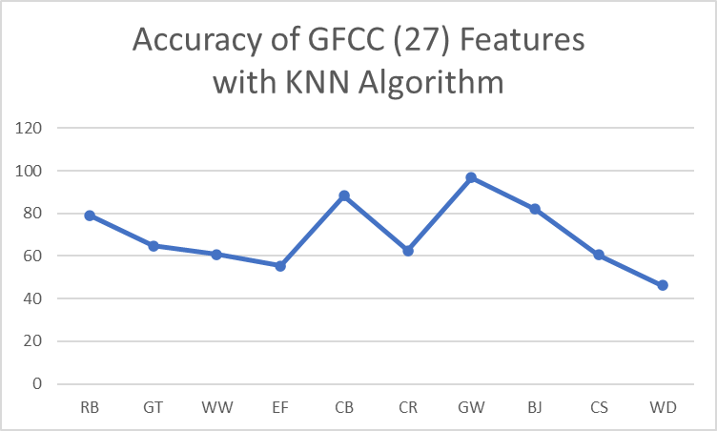

MFCC (SVM)
Bird species | precision | recall | f1 score | Accuracy | support
RB | 0.88 | 0.88 | 0.88 | 81.81 | 44
GT | 0.68 | 0.72 | 0.7 | 88.23 | 51
WW | 0.63 | 0.63 | 0.63 | 77.08 | 48
EF | 0.62 | 0.38 | 0.47 | 81.03 | 58
CB | 0.74 | 0.82 | 0.78 | 81.13 | 53
CR | 0.81 | 0.75 | 0.78 | 90.76 | 65
GW | 0.73 | 0.92 | 0.82 | 84.21 | 57
BJ | 0.85 | 0.81 | 0.83 | 70.49 | 61
CS | 0.66 | 0.73 | 0.69 | 95.12 | 41
WD | 0.73 | 0.85 | 0.78 | 76.59 | 47

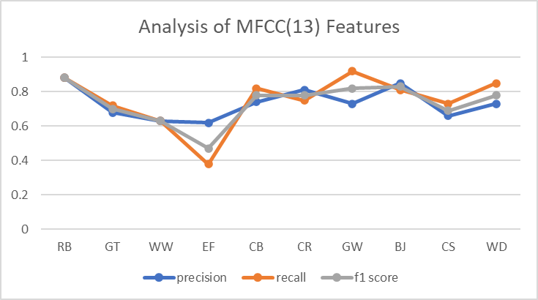
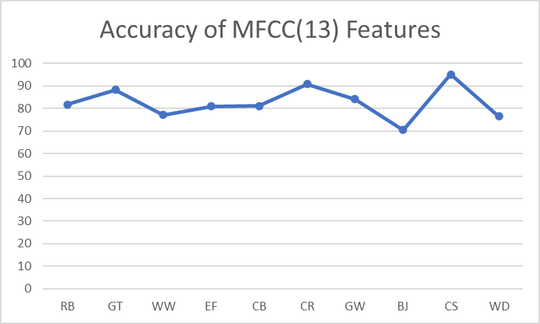

Bird species | precision | recall | f1 score | Accuracy | support
RB | 0.86 | 0.84 | 0.85 | 83.82 | 68
GT | 0.64 | 0.71 | 0.67 | 70.51 | 78
WW | 0.67 | 0.75 | 0.71 | 75.32 | 77
EF | 0.54 | 0.28 | 0.37 | 28.08 | 89
CB | 0.76 | 0.85 | 0.8 | 84.81 | 79
CR | 0.78 | 0.93 | 0.85 | 92.64 | 68
GW | 0.76 | 0.92 | 0.83 | 68.35 | 79
BJ | 0.84 | 0.79 | 0.81 | 79.22 | 77
CS | 0.75 | 0.72 | 0.73 | 71.64 | 67
WD | 0.76 | 0.76 | 0.76 | 76.08 | 46

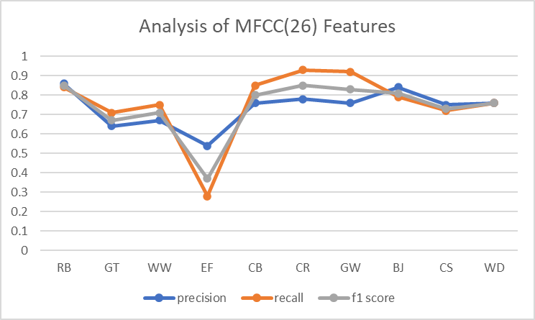
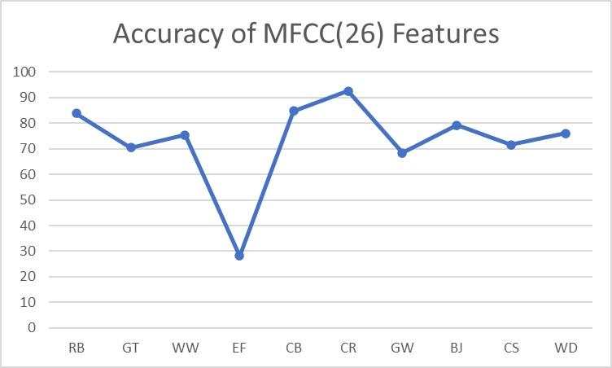

Bird species | precision | recall | f1 score | Accuracy | support
RB | 0.77 | 0.86 | 0.81 | 85.71 | 56
GT | 0.61 | 0.71 | 0.66 | 71.42 | 63
WW | 0.55 | 0.72 | 0.62 | 71.62 | 74
EF | 0.49 | 0.37 | 0.42 | 36.9 | 84
CB | 0.84 | 0.8 | 0.82 | 80.24 | 81
CR | 0.88 | 0.61 | 0.72 | 60.65 | 61
GW | 0.87 | 0.88 | 0.88 | 88.4 | 69
BJ | 0.77 | 0.87 | 0.82 | 86.67 | 90
CS | 0.73 | 0.74 | 0.74 | 74.32 | 74
WD | 0.89 | 0.75 | 0.82 | 75 | 56

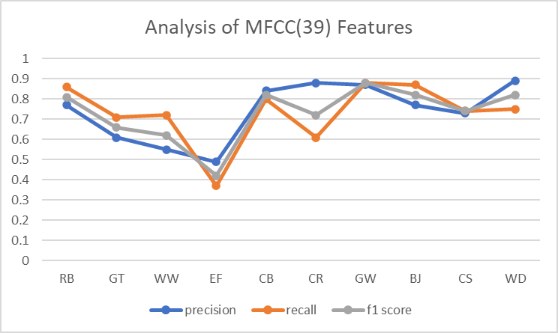
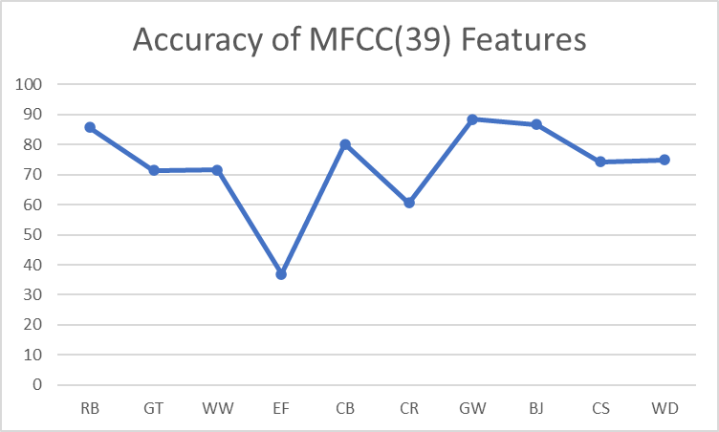

Bird species | precision | recall | f1 score | Accuracy | support
RB | 0.93 | 0.79 | 0.85 | 78.87 | 71
GT | 0.65 | 0.86 | 0.74 | 85.91 | 71
WW | 0.68 | 0.69 | 0.69 | 69.41 | 85
EF | 0.54 | 0.39 | 0.45 | 39.47 | 76
CB | 0.78 | 0.8 | 0.79 | 80.45 | 87
CR | 0.75 | 0.88 | 0.81 | 87.75 | 49
GW | 0.9 | 0.85 | 0.87 | 84.72 | 72
BJ | 0.71 | 0.75 | 0.73 | 74.68 | 79
CS | 0.64 | 0.66 | 0.65 | 65.67 | 67
WD | 0.86 | 0.75 | 0.8 | 74.5 | 51

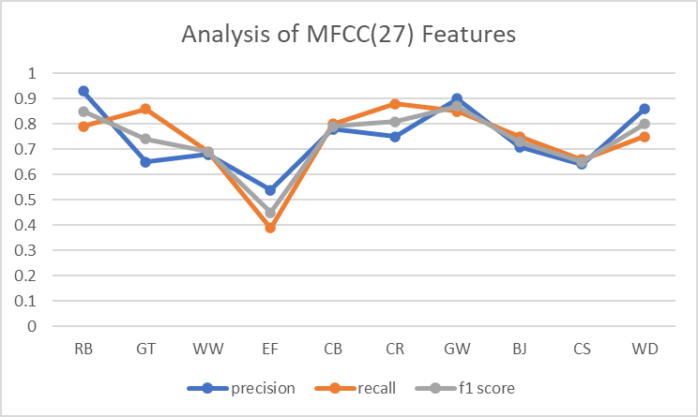
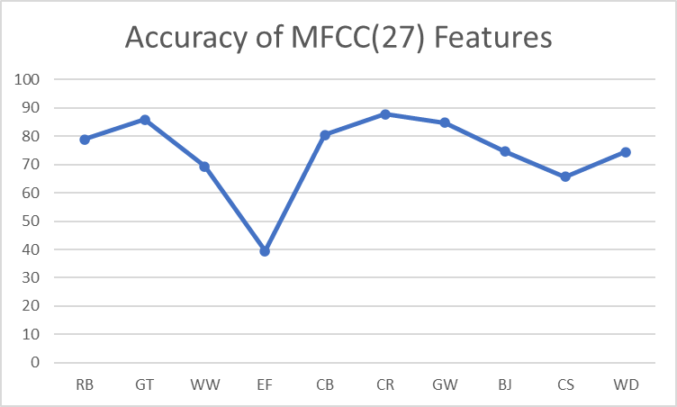

LFCC (SVM)
Bird species | precision | recall | f1 score | Accuracy | support
RB | 0.69 | 0.75 | 0.72 | 64.93 | 77
GT | 0.69 | 0.75 | 0.72 | 52.77 | 72
WW | 0.55 | 0.78 | 0.64 | 58.73 | 63
EF | 0.58 | 0.48 | 0.53 | 60.91 | 87
CB | 0.79 | 0.76 | 0.77 | 60 | 70
CR | 0.92 | 0.58 | 0.71 | 88.9 | 62
GW | 0.93 | 0.9 | 0.91 | 94.77 | 59
BJ | 0.76 | 0.8 | 0.78 | 73.17 | 82
CS | 0.77 | 0.81 | 0.79 | 74.04 | 81
WD | 0.78 | 0.69 | 0.73 | 61.81 | 55

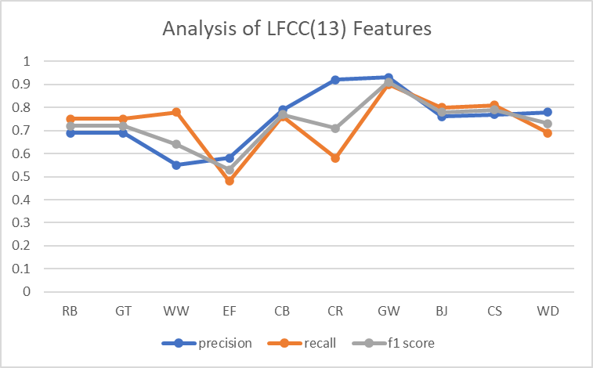
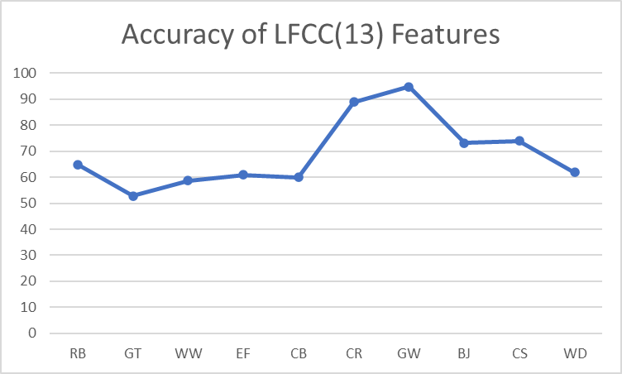
Bird species | precision | recall | f1 score | Accuracy | support
RB | 0.69 | 0.69 | 0.69 | 68.75 | 64
GT | 0.69 | 0.76 | 0.73 | 76.47 | 68
WW | 0.47 | 0.69 | 0.56 | 68.83 | 77
EF | 0.64 | 0.41 | 0.5 | 41.37 | 87
CB | 0.82 | 0.77 | 0.79 | 76.62 | 77
CR | 0.89 | 0.74 | 0.81 | 73.84 | 65
GW | 0.8 | 0.86 | 0.83 | 85.96 | 57
BJ | 0.76 | 0.67 | 0.71 | 67.46 | 83
CS | 0.77 | 0.88 | 0.82 | 87.8 | 82
WD | 0.78 | 0.73 | 0.75 | 72.91 | 48

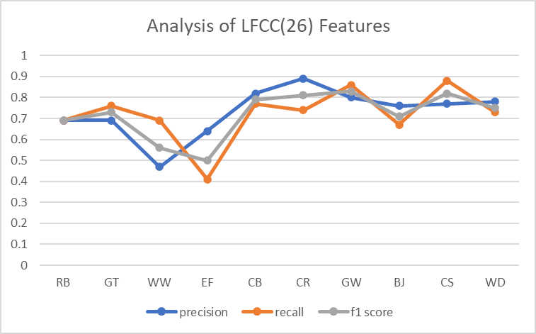
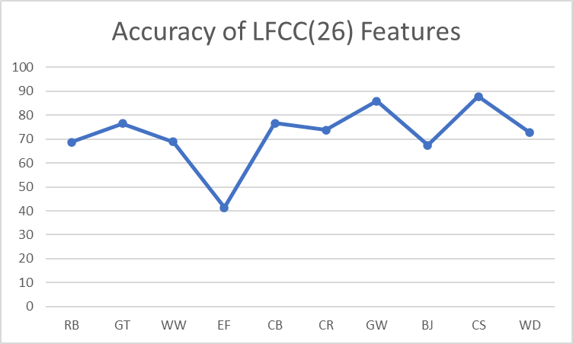

Bird species | precision | recall | f1 score | Accuracy | support
RB | 0.72 | 0.74 | 0.73 | 74.24 | 66
GT | 0.73 | 0.77 | 0.75 | 76.71 | 73
WW | 0.51 | 0.64 | 0.56 | 63.88 | 72
EF | 0.53 | 0.46 | 0.5 | 46.42 | 84
CB | 0.77 | 0.66 | 0.71 | 66.23 | 77
CR | 0.88 | 0.64 | 0.74 | 63.63 | 55
GW | 0.88 | 0.82 | 0.84 | 81.66 | 60
BJ | 0.78 | 0.79 | 0.79 | 79.06 | 86
CS | 0.71 | 0.82 | 0.76 | 82.05 | 78
WD | 0.7 | 0.74 | 0.72 | 73.68 | 57

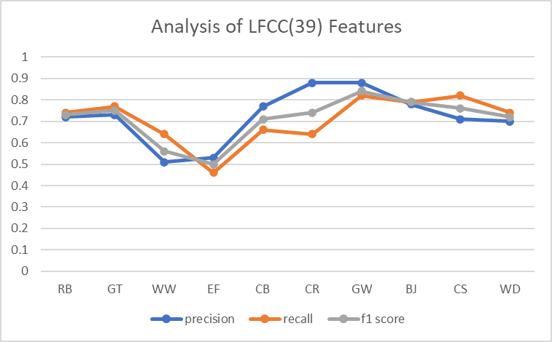
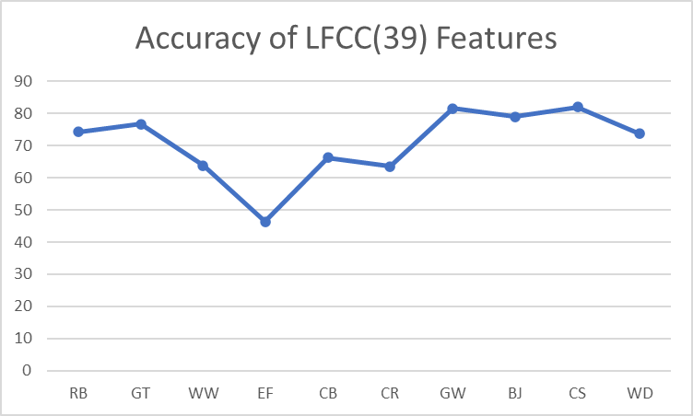

Bird species | precision | recall | f1 score | Accuracy | support
RB | 0.88 | 0.69 | 0.77 | 69.01 | 71
GT | 0.71 | 0.8 | 0.75 | 80.28 | 71
WW | 0.61 | 0.65 | 0.63 | 64.7 | 85
EF | 0.57 | 0.46 | 0.51 | 46.05 | 76
CB | 0.89 | 0.75 | 0.81 | 74.71 | 87
CR | 0.75 | 0.8 | 0.77 | 98.21 | 56
GW | 0.85 | 0.93 | 0.89 | 87.5 | 72
BJ | 0.69 | 0.8 | 0.74 | 68.35 | 79
CS | 0.68 | 0.81 | 0.74 | 80.59 | 67
WD | 0.77 | 0.71 | 0.73 | 70.58 | 51

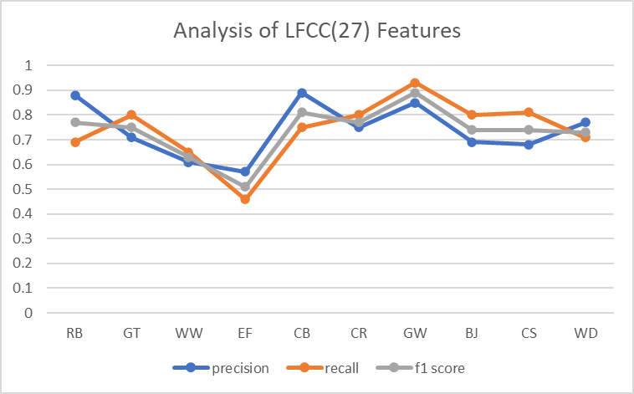
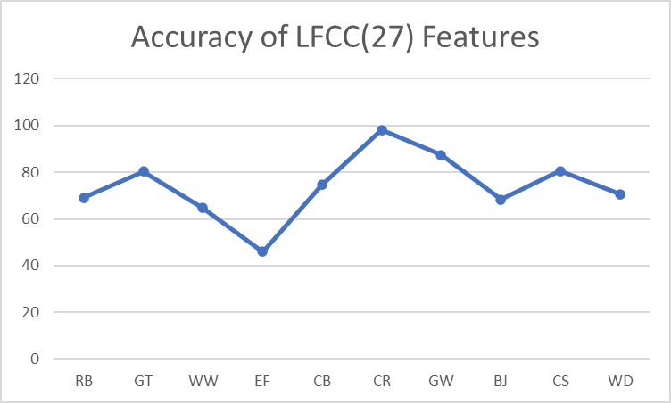

GFCC(SVM)
Bird species | precision | recall | f1 score | Accuracy | support
RB | 0.67 | 0.81 | 0.74 | 81.15 | 69
GT | 0.65 | 0.64 | 0.64 | 63.89 | 72
WW | 0.4 | 0.54 | 0.46 | 54.16 | 72
EF | 0.69 | 0.41 | 0.52 | 41.46 | 82
CB | 0.74 | 0.8 | 0.77 | 80 | 80
CR | 0.74 | 0.68 | 0.71 | 68 | 50
GW | 0.74 | 0.9 | 0.81 | 90 | 60
BJ | 0.76 | 0.88 | 0.81 | 87.5 | 88
CS | 0.83 | 0.74 | 0.78 | 74.35 | 78
WD | 0.9 | 0.49 | 0.64 | 49.12 | 57

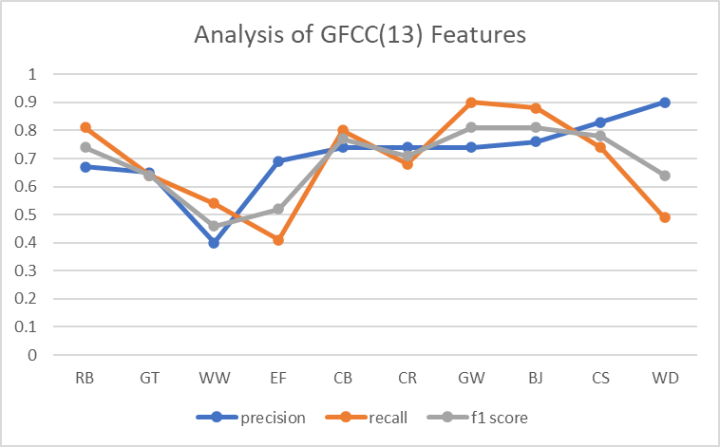
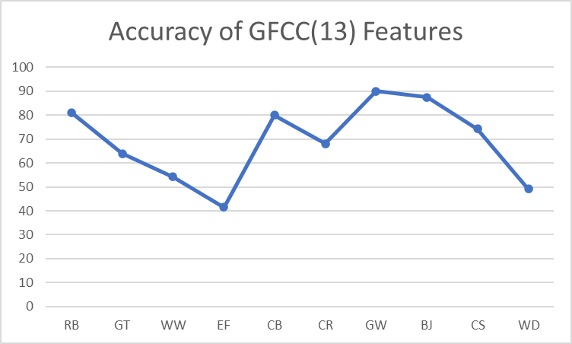
Bird species | precision | recall | f1 score | Accuracy | support
RB | 0.72 | 0.77 | 0.75 | 77.33 | 75
GT | 0.74 | 0.57 | 0.65 | 57.14 | 70
WW | 0.51 | 0.64 | 0.57 | 63.75 | 80
EF | 0.72 | 0.51 | 0.59 | 50.54 | 91
CB | 0.8 | 0.8 | 0.8 | 79.51 | 83
CR | 0.86 | 0.62 | 0.72 | 62.06 | 58
GW | 0.7 | 0.96 | 0.81 | 95.91 | 49
BJ | 0.61 | 0.81 | 0.7 | 81.33 | 75
CS | 0.78 | 0.81 | 0.79 | 80.82 | 73
WD | 0.79 | 0.61 | 0.69 | 61.11 | 54

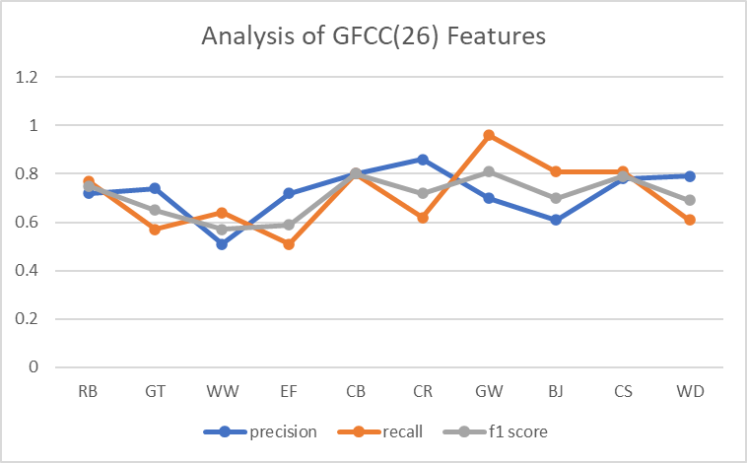

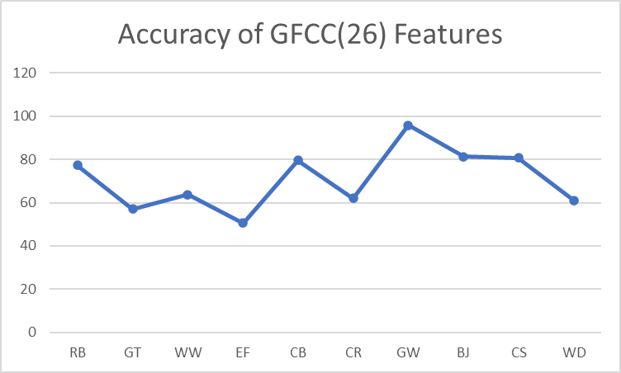
Bird species | precision | recall | f1 score | Accuracy | support
RB | 0.69 | 0.82 | 0.75 | 82.14 | 56
GT | 0.75 | 0.58 | 0.65 | 57.74 | 71
WW | 0.46 | 0.63 | 0.53 | 63.29 | 79
EF | 0.68 | 0.57 | 0.62 | 57.14 | 84
CB | 0.78 | 0.85 | 0.82 | 84.93 | 73
CR | 0.79 | 0.66 | 0.72 | 66.07 | 56
GW | 0.8 | 0.94 | 0.86 | 94.11 | 68
BJ | 0.74 | 0.84 | 0.78 | 83.51 | 91
CS | 0.87 | 0.73 | 0.79 | 72.97 | 74
WD | 0.86 | 0.55 | 0.67 | 55.35 | 56

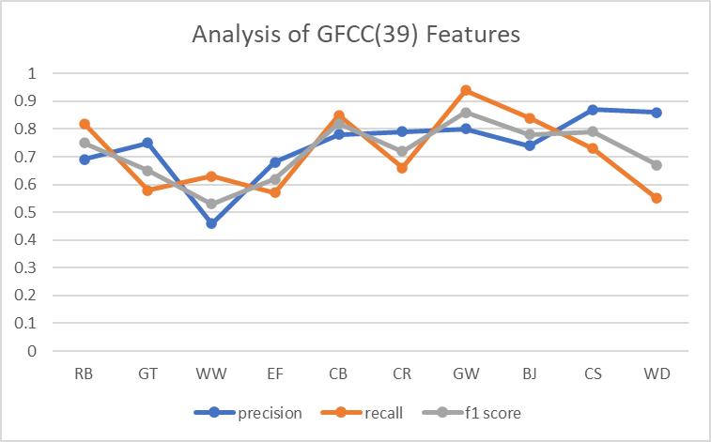
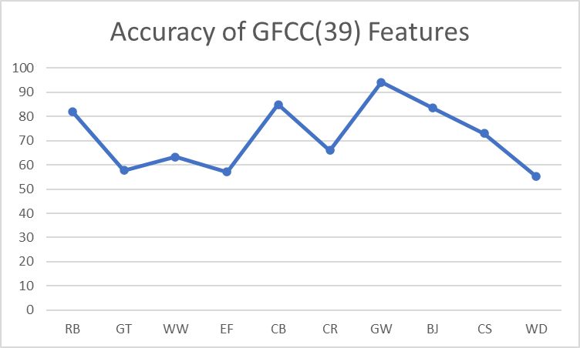

Bird species | precision | recall | f1 score | Accuracy | support
RB | 0.6 | 0.69 | 0.64 | 69.01 | 71
GT | 0.76 | 0.68 | 0.72 | 67.6 | 71
WW | 0.49 | 0.49 | 0.49 | 49.41 | 85
EF | 0.62 | 0.54 | 0.58 | 53.94 | 76
CB | 0.77 | 0.7 | 0.73 | 94.25 | 87
CR | 0.83 | 0.61 | 0.71 | 61.22 | 49
GW | 0.69 | 0.97 | 0.8 | 97.22 | 72
BJ | 0.71 | 0.81 | 0.76 | 81.01 | 79
CS | 0.69 | 0.64 | 0.67 | 64.17 | 67
WD | 0.68 | 0.59 | 0.63 | 58.82 | 51

